**God’s Word is meant to be understood; and it can be!**

**Initial considerations**

**1. Your opinion doesn’t matter and neither does mine. This leads to #2**

**2. The text of Scripture is what matters. It is “God-breathed.” Truth is objective.**

**3. The goal of all interpretation is the author’s intent.**

**4. It should be a joy and a privilege to realize we are wrong, especially when we find out what is right.**

**5. Good readers make good interpreters. Caring about meaning makes you a better reader. When we stop caring, we miss meaning.**

**6. Remember: Common sense is not common and we often don’t have sense.**

**7. Literal interpretation is normal interpretation.**

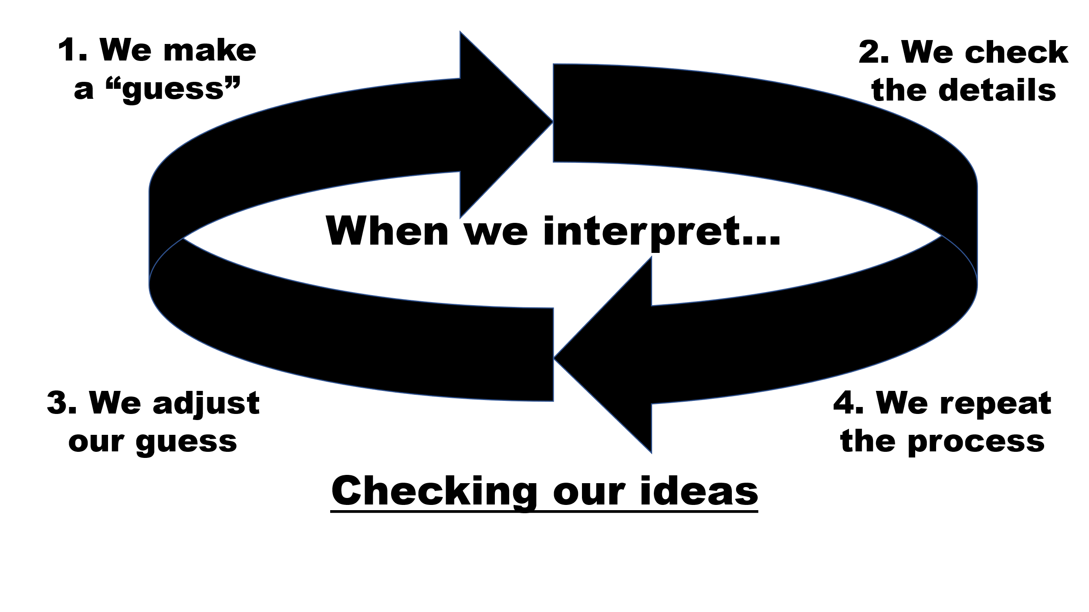

**Key Principles**

**1. Context: Likely the “queen” of interpretive principles.**

* **Broader – Who is the audience? What is the subject? Focus on Synthesis**
* **Immediate – Details: Focus on Analysis**

**2. Grammer: Do I understand the words as they were originally understood?**

* **Etymology = background/development of the word**
* **Usage – usage often determines meaning**

**3. Historical/Cultural Setting**

**4. Comparing Scripture with Scripture: Color within the lines, but make sure there are lines. “Different” is not necessarily a contradiction.**

**5. Big word, important meaning: Illocutionary Force = “What did He mean by that?**

**“You’re going downtown today” and stuff like that.**

**Methodology: Some of the ways we discover the Author’s intention**

**1. Prayer: Jas. 4:2**

**2. Meditation: Another indispensable aspect (Ps. 1).**

**3. Be diligent: 2 Timothy 2:15**

**4. Observation: A critical element to meditation. Read the passage. Then, read it again. Then, again. When you are done, read it again.**

**Good observation leads to good interpretation. Many people see things that are there. Good observers see things that are actually there.**

**5. Look for the little things; words you don’t understand, verbs, words that indicate movement of thought, like prepositions (For, therefore, like, and such).**

**6. Paraphrase: This helps you see if you understand it.**

**7. Interpretation: Observation seeks to know what it meant to them. Interpretation asks what it means to me.**

**8. Consult others: Can be helpful, can be dangerous.**

**9. Application: How do I use this truth in my life?**

**A word of caution**