**Romans 1:16-32 – Everything we want isn’t good for us**

**Main: Sin isn’t just wrong, it’s enslaving**

**1. The reality of wrath 1:16-18a**

**1:16-17 God’s righteousness is revealed**

* **The good news reveals God’s righteousness**
* **“The just by faith shall live”**

**1:18 – God’s wrath is revealed**

* **“Is revealed” is emphatic in the original**
* **Humanity’s sin has not escaped His notice and God reveals His anger toward it**
* **Impiety = irreligious spirit “Wrongness” of man’s behavior**
* **“Suppress truth” Bad enough to break God’s standards, but men try to hold back truth. God is angry because of sin and suppression of truth.**
* **Idolatry is one example of this suppression, but there are other ways later.**

**2. The reason for wrath: Suppression of truth 1:18b-23**

* **Why was Paul so anxious to get the good news of God’s deliverance to them? Because our sin results in enslavement.**
* **Paul wanted us to know how justified people could be delivered from it.**
* **Men know better and actually suppress truth**
* **The more complex the system, the more likely it was created**
* **Humanity sees the reality of God: His power and the reality of divinity**
* **Special revelation: God’s Word - Some aspects of God’s nature cannot be known without. Christianity is a revealed religion – Jn. 1:18**
* **General revelation: Two aspects 1) Creation Rom. 1:19-20 and 2) Conscience – Rom. 2:14-15**
* **General revelation is not sufficient to save, but it is sufficient to condemn**
* **Illustration of the Persian seeker**
* **Story of Martin Luther: A seeker**
* **God is a rewarder of those who seek Him**

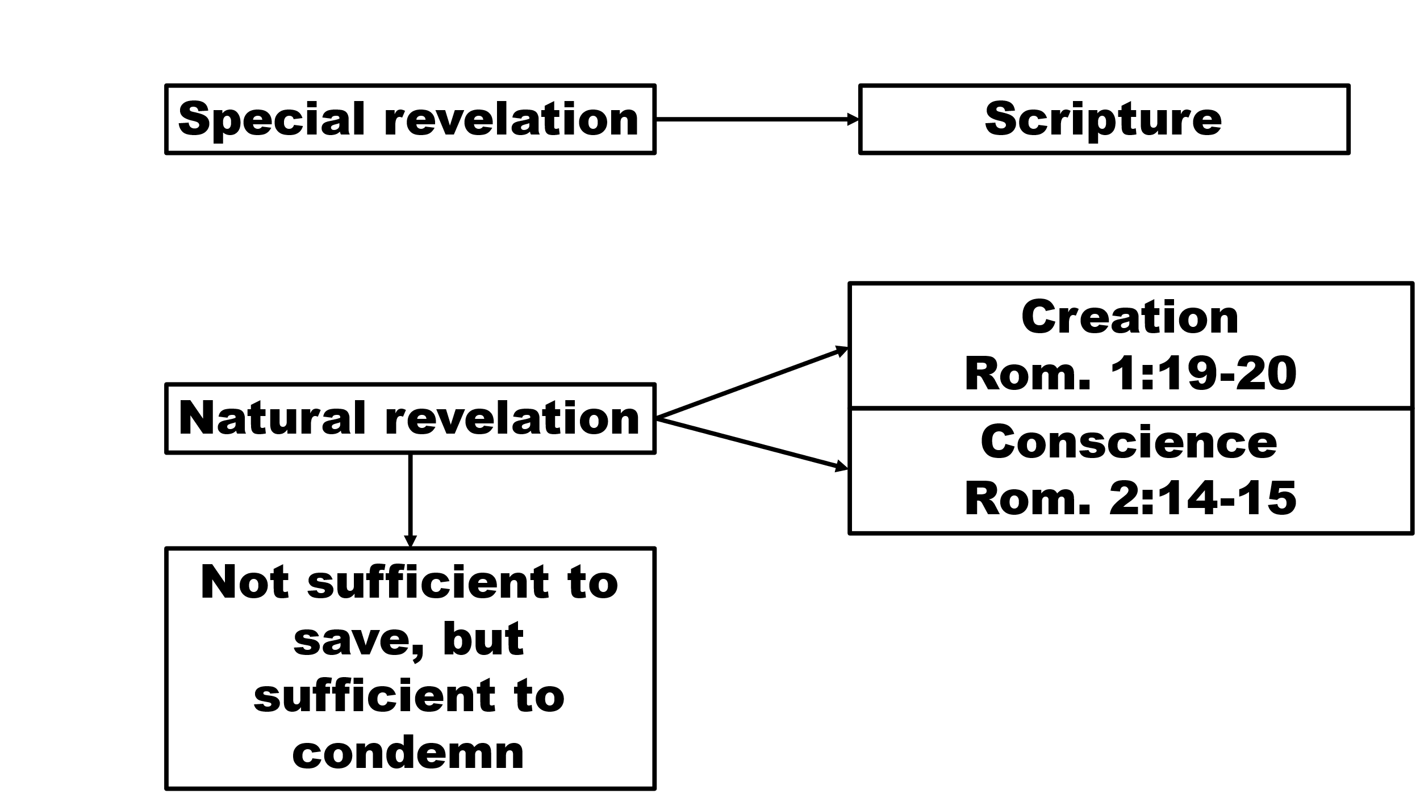

**3. The result of wrath: Enslavement 1:24-31**

* **Paul gives a long list of sins to illustrate enslavement and begins with two examples, both involving same sex relationships**
* **1:24, 26, 28 “God…gave them up…gave them up…gave them over”**
* **God’s response to idolatry is to give men over to that which cannot save**
* **Prov. 1:20-33 = An example of this**
* **God turned people over to perversion and enslavement in their bodies**
* **1:29-32 – Notice that the enslavement extends to virtually any sin**
* **All of us stand guilty; all of us stand condemned and enslaved**
* **No one is in a position to think we are better than another**
* **No one is in a position to hate someone for their sin**
* **All of us should condemn what is wrong and that includes our own lives**
* **The issue here isn’t how we judge others; the issue is what happens to all of us when we sin.**
* **The only path to freedom is: 1) Faith alone in Christ alone to be justified and 2) Living by the Spirit in the power of the risen Christ**

**More to come…**