**Romans Review - Main idea: Deliverance from Wrath**

**God is getting us ready to rule**

**Theme verses: 1:16-17**

**Paul is proud of the good news he preaches that can bring righteousness to all who believe and deliver believers from enslavement to sin**

* **Key terms:** 
  + **Salvation = “To be delivered from” whatever the context indicates; in this case, wrath or enslavement to sin; deliverance**
  + **“Wrath” or the enslaving consequences of sin**
* **Romans 1;18-3:20 – Condemnation and enslavement**
  + **God is angry at unrighteousness in humanity and delivers men over to the enslavement to sin (wrath)’**
  + **The Gospel has the power to deliver people from enslavement to sin**
  + **Humanity has turned its back on God in spite of obvious existence of a Creator**
  + **None are righteous and so need God’s (3:19-25)**
* **Romans 3:31-4:5 – Justification**
  + **The only way to peace with God is to be righteous, but men are not**
  + **So, the only course left is to give God’s righteousness as a gift by grace through faith**
  + **Righteousness (justification) is based on the cross (4:25) and it brings peace with God (5:1).**
* **Romans 5:1-8:39 – Sanctification**
  + **The death of Christ brings justification. The life of Christ brings salvation from wrath (enslavement) to the justified (4:25; 5:9-10)**
  + **The key issue: 8:10; HOW DO BELIEVERS GET A “DEAD” BODY ALIVE? Paul explains how the life of God can be expressed through a body that is disconnected from God, dead or uncooperative.**
  + **5:9-10 = Key verses that explain we can be delivered from enslavement by the risen Christ.**
  + **5:12-21 – Adam brought sin, death, and enslavement. Jesus brought life and the possibility of freedom.**

**6:1-23 – Since believers are united to Christ, we have a new identity, new life, and what we need to live our new life**

* + **7:1-25 - Though married to Christ, the “monkey wrench” to growth is that believers are still in the body and enslaved to its desires**
  + **8:1-11 – Believers don’t have to serve sin, if they walk according to the Spirit**
  + **The key is a mind set on the things of the Spirit. Believers, unlike unbelievers now have options other than sin.**
  + **Believers who walk in the Spirit are led by the Spirit and living out their “adult son” life (Rom. 8:14; Gal. 4:1-7)**
  + **All children of God are “Heirs of God”. Those who suffer with Christ are His co-heirs – 2 Tim. 2:12a; Rev. 2:25-27**

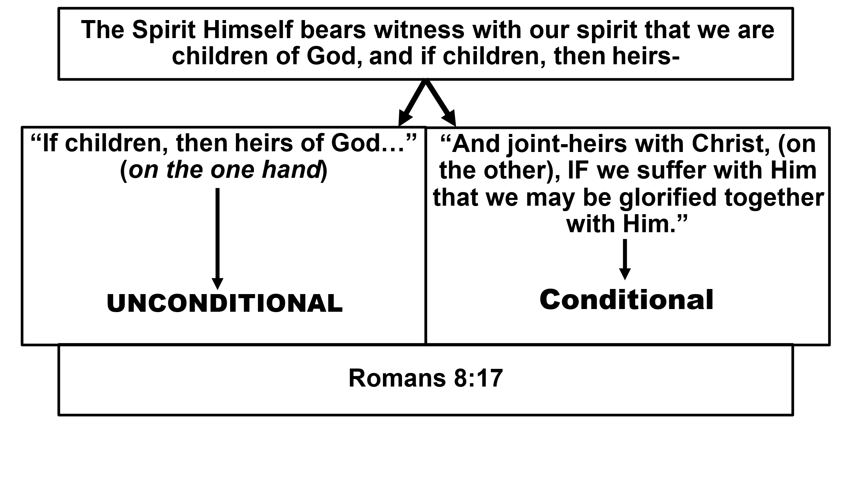

* + **Suffering and co-heirship become the focus of 8:18-30**
  + **God’s purpose involves aiding believers who suffer with Christ to become joint-heirs with Jesus**
  + **Even Creation is pointed toward the Kingdom! 8:20-25**
  + **Creation is in pain, desires a better world 8:22-23**
  + **Our support in suffering Part I 8:19-30**
    - **Motivation of the Kingdom & the glories that follow - 8:18-25**
    - **The Spirit’s partnership in prayer 8:26-27**
    - **The promise to co-heirs; all things will work together for good 8:28 (those who love God…called acc’d. to His purpose)**
    - **The ultimate glorification of the co-heirs 8:29-30**
      * **“FOR, whom He foreknew” connects to v. 28**
      * **Known before time who would suffer with Him.**
      * **Predestined to be more like Jesus**
      * **Called to reward – 2 Pet. 1:10-11; Mt. 21;1F.**
      * **Vindicated by God – Rom. 3:4**
      * **Glorified with Christ (full circle with 8:17b)**