**Ruling with Christ: a believers greatest privilege**

**The Bible = a story of God’s efforts to establish His Kingdom on earth**

**The purpose for which God created becomes the purpose of the created – Gen. 1:28; Rev. 22:5**

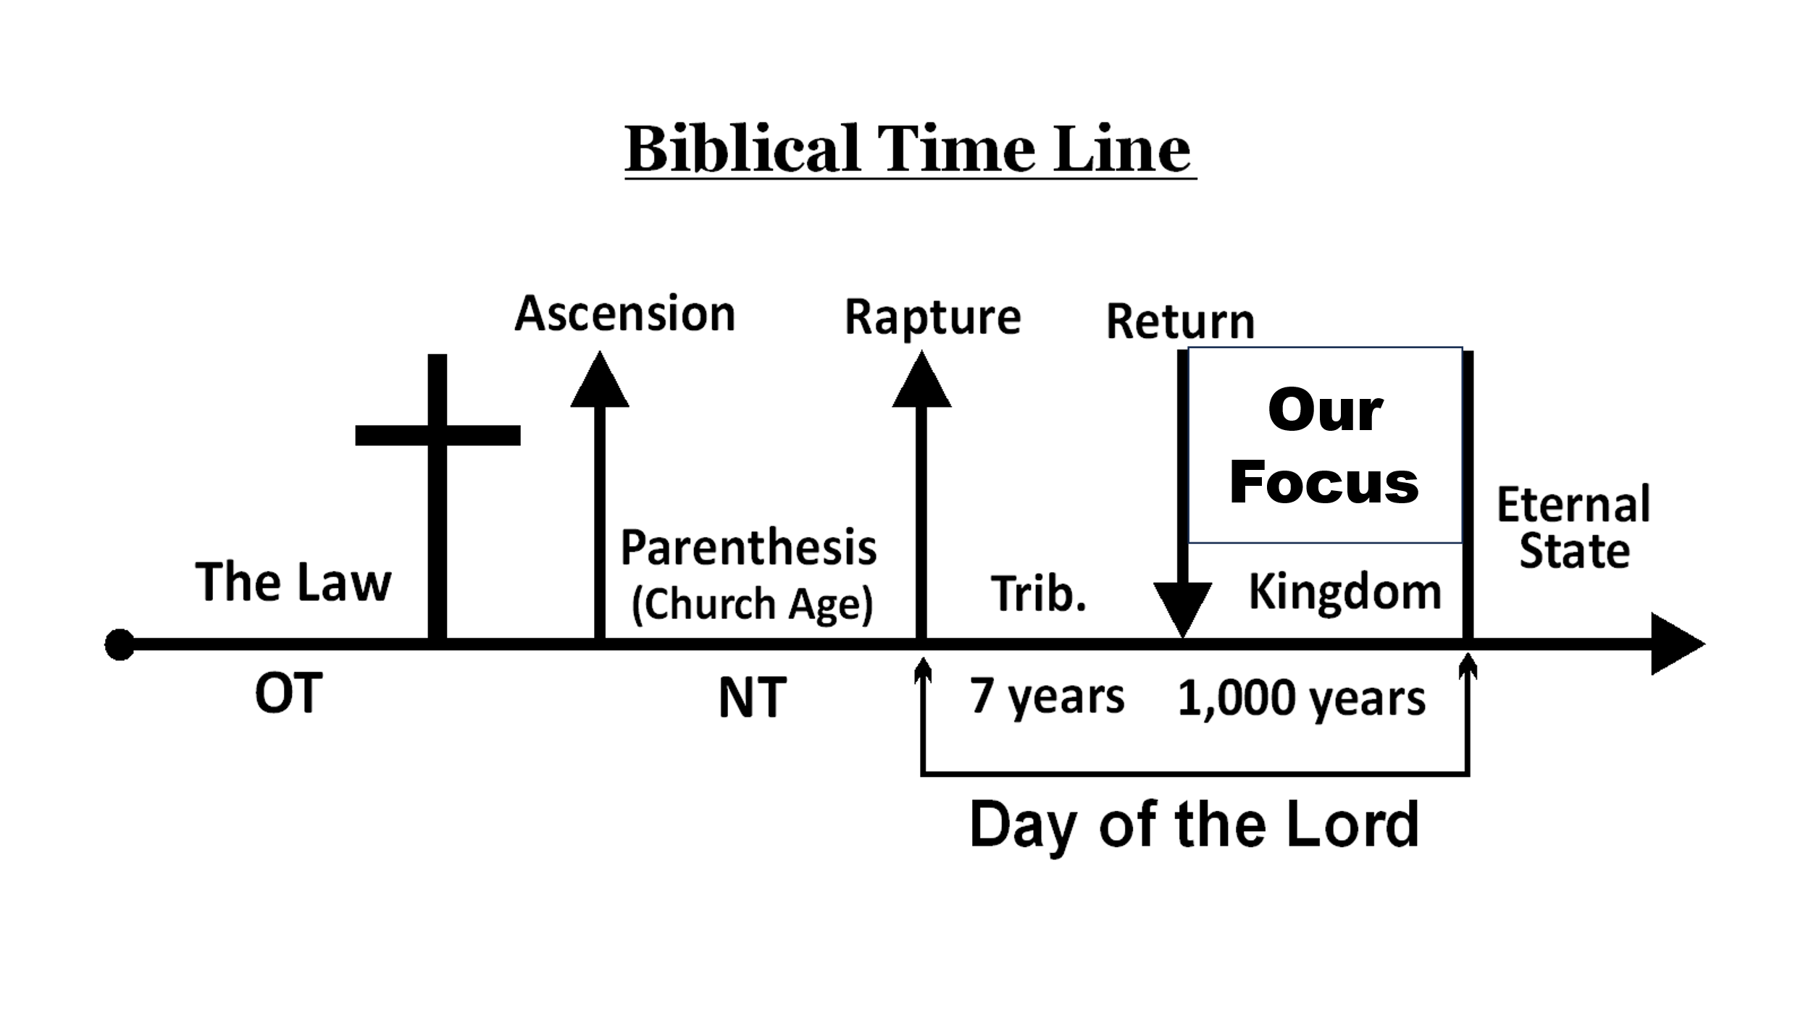

**1. The Abrahamic Covenant – Land, Seed, Blessing**

**2. The Davidic Covenant – Eternal rule**

* **2 Samuel 7:12-16**
* **Psalm 2**
* **Luke 1:30-33**
* **Hebrews 1:1-2, 4-5, 6, 8-9**

**3. Romans 8:10-17 (Review) – Living an adult life**

* **Galatians 4:1-7 – Heirs of God (unconditional inheritance; all believers)**
* **Romans 8:16-17 – Two heirships realized**
  + **Entering the Kingdom = Simple faith – John 3:3-4, 16**
  + **Heirs of God (all believers)**
  + **Co-heirs with Christ (Conditional; believers who suffer with Him)**
    - **Requirements**
      1. **Endurance: 2 Timothy 2:12; Rev. 2:25-27**
      2. **Character:**

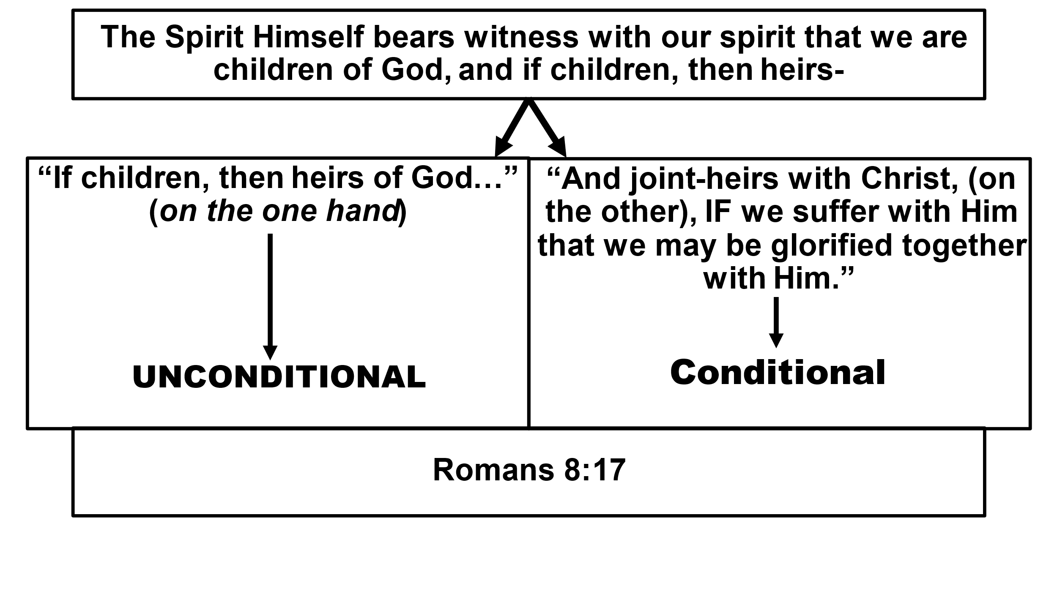

**“All glory is fleeting” – George Patton; “Now man’s reign is through” – In the Year 2525 – Zager and Evans; More accurately, “We’ve only just begun!”**