**Romans 9 = Israel is under God’s wrath: Don’t make their mistakes!**

**Overview of chapter 9 - “So, what happened to Israel?”**

**1. Paul’s concern for Israel – 1-5**

**2. Israel’s unbelief and God’s plan - 6-13**

**3. God’s purpose and His choices – 14-29**

**4. The remnant and the collision – 30-33**

**Paul’s concern for Israel**

**9:1-2 - Paul’s concern is shown by HIs words, His conscience and The Holy Spirit**

**9:3-4 - The idea here is something like, “I almost wish I could die for Israel” - 2 Sam. 18:33**

**9:4-5 – Seven examples of God’s favor to Israel**

**“Israel’s unbelief lines up with Scripture, it has not failed, and it is part of God’s plan for the world. Israel’s future is sure and nothing has happened to change that.”**

**I. God’s grace is selectively channeled, as is His right 9:6-13**

**A. God chose Isaac over Ishmael**

**God wanted the blessing to flow through Abraham and Sarah with Isaac**

**God wanted blessing to come through the child of promise, not the flesh**

**B. God wanted Jacob to be the vehicle of promise 9:10-13**

**God’s purpose came by His choice, not their actions**

**“Election” here involves God’s choice and the one chosen to be the channel of God’s purpose to bless and reach the world**

**9:11-12 – The issue here has nothing to do with their eternal life, one way or another! God is choosing the vehicles through which He will reach the world.**

**“Loved…hated” –choice, not emotion – Mal. 1:1 -3 The issue was temporal, not eternal. These passages do not deal with election to eternal life**

**9:13 – In Paul’s day, the believing remnant of Israel had also received mercy.**

**II. God’s mercy and wrath in reference to Israel 9:14-18**

**9:14-16 – No one can demand mercy; its very nature comes from our failure!**

* **God has a right to show mercy and to withhold it, as He did with Pharaoh.**
* **Again, the issues here are not eternal or salvific issues, “All God really does is to confirm and extend a process of hardening that Pharaoh himself had initiated”! – Hodges, p. 273 “Romans” (Ex. 5:1-2) Pharoah “started it”, as did Israel Ex. 5:1-2; Rom 10:21; Mtg. 12:13-15 after the blasphemy of the Spirit Mt. 12:38-41**
* **As humans, we cannot possibly know all that goes into God’s decisions. As creatures, we have no right to judge God!**

**9:27-28 – God has chosen to pour out His temporal wrath on national Israel and to show mercy to His true children, both Jew and Gentile.**

**God’s present mercy is on a small number of Israel; the Remnant.**

**9:29 – “Sodom…Gomorrah” received temporal destruction**

**9:30-33 – The Gentiles didn’t deserve mercy; Israel’s pursuit of +R was not, and is not, faith-based.**

* **Israel’s hardening came as a result of their sin**
* **Nothing at all is said here about a “predestination” to hell.**
* **Israel failed in Step #1 and then, by extension, Step #2 – Rom. 10:9-10**

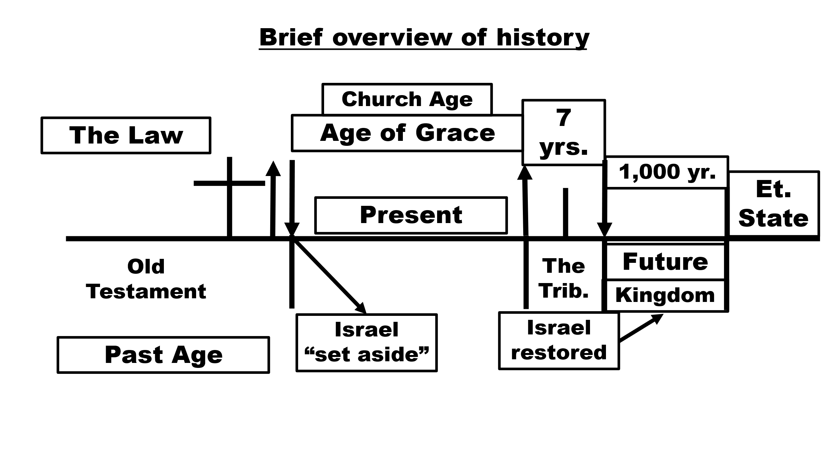

**Applications**

* **Can’t understand history properly without understanding Israel’s role**
* **We can’t properly understand the Bible without understanding Israel’s role**
* **The world doesn’t revolve around the Gentiles**
* **Nor does history revolve around me; narcissists misunderstand the way the world works and how history works**
* **A key aspect of the A/C was to reach the world, once the Church is gone, God will again turn to Israel**
* **Israel still has a future in the plans and purposes of God. They have been temporarily set aside.**
* **The salvation of the Gentiles is Appl**
* **designed to provoke jealousy Israel**
* **God is free to choose how to glorify Himself and reach the world**
* **We are not Israel, we are ChurA**

**Applications**

**Applications**

* **We can’t understand history properly without understanding Israel’s role**
* **We can’t properly understand the Bible without understanding Israel’s role**
* **The world doesn’t revolve around the Gentiles**
* **Nor does history revolve around me; narcissists misunderstand the way the world works and how history works**
* **A key aspect of the A/C was to reach the world, once the Church is gone, God will again turn to Israel**
* **Israel still has a future in the plans and purposes of God. They have been temporarily set aside.**
* **The salvation of the Gentiles is designed to provoke jealousy Israel**
* **God is free to choose how to glorify Himself and reach the world**
* **We are not Israel, we are Church**
  + **Confusion in this area leads to many problems, like infant baptism: Roman citizens? Like OT circumcision?**
    - **OT applied incorrectly, like the Crusades, tattoos**
    - **Denominational proliferation**
  + **We’re reading “someone else’s mail**