**The purpose and message of John the Baptist**

**MAIN: We can help prepare hearts for Jesus**

**1. Hope from devastation – Isa. 40:1-5**

**2. The voice – Mt. 3:1-3; Jn. 1:23**

**3. Preparing the way of the Lord – Lk. 3:3-6**

**4. The final OT message – Mal. 4:3-6**

* **Remember the Law: “you made a commitment”**
* **Eli’s comin’**
* **So is the Day of the Lord**
* **John is his name, repentance is his game**

**5. John the Baptist ID’d – Lk. 1:15-17**

**6. John’s message of preparation - Repent and be baptized – Mk. 1:3-5**

**7. John's message was the start, not the end goal – Acts 19:4**

**8. “Are you willing to accept it?” - Mt. 11:11-15**

**9. Not what they expected – Mt.11:16-19**

**10. After the Transfiguration, it comes together – Mt. 17:9-13**

**11. The message Jesus commanded – Lk. 24:46-49**

**12. The message John proclaimed – John 20:30-31**

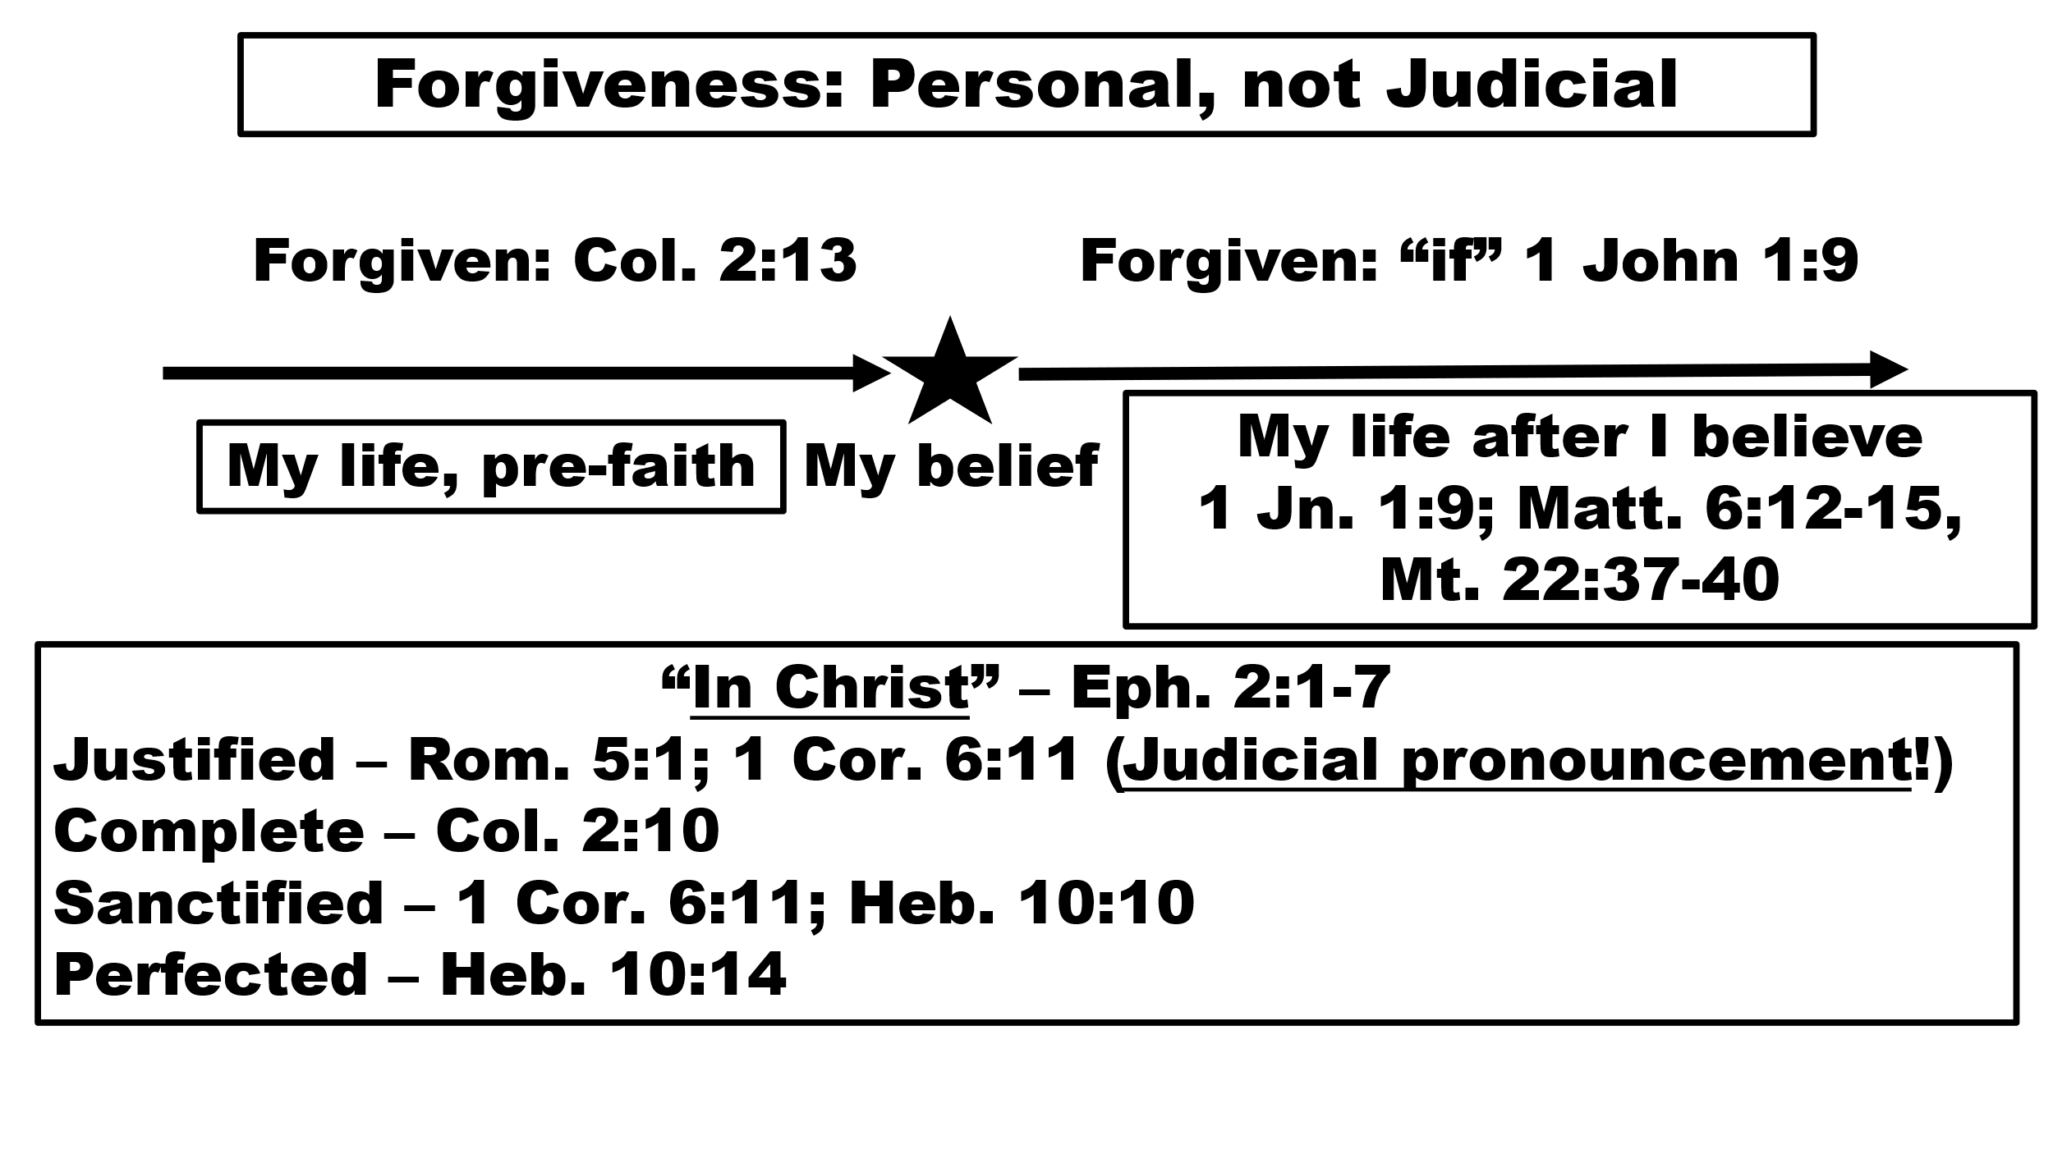

**What we can learn**