**Preparation for John: Isael to the Church - To whom much is given…**

**How do you respond to God’s goodness to you? Luke 12:35-48 = Much is given?**

**1. The ministry of John: Turning Israel back to God**

* **Mal. 4:4-6 - Elijah; Lk. 1:15-17**
* **Mk. 1:3-5 – His message; Acts 19:4 = Preparation to believe**
* **Mt. 11:11-15 – Was Israel willing? Mt. 17:9-13 – Nope!**
* **Mt. 27:20-26 – Israel took the blame (Jews in Palestine)**

**2. Israel in the New Testament (in Palestine)**

* **They had taken the blame for Jesus’ crucifixion (Mt. 27:20-26)**
* **They had not responded to John (Mt. 17:12; Mk. 9:13)**
* **Repentance needed for forgiveness (Mk. 1:4; Acts 2:36-38)**
* **National repentance was still needed Pentecost (Mt. 12:31-41; Acts 3:17-21)**
* **Local Jews who believed needed repentance and baptism (Acts 2:36-39: 1 Jn. 5:1). Notice the emphasis on children (Mt. 27:25; Acts 2:39)**
* **The Samaritans and John’s disciples also receive the Spirit “late” (Acts 8:12; 19:4).**
* **Several things are of interest here:**
  + **Water baptism for repentance and forgiveness had been rejected by those who heard the preaching of the Kingdom by both John and Jesus (Mt. 17:12; John 1:11). Now, for them, repentance and baptism is necessary to be forgiven and to receive the gift from the One who baptized by the Spirit. This included local Jews, like Paul, the Samaritans and John’s disciples (Acts 19:4; 22:16).**
  + **They would not be admitted into the Church without it.**
  + **No Jew outside this area, nor any Gentile, ever receives the Spirit any time but at the time of faith. Later it is clear this is standard practice for all Jews and Gentiles. (Romans 8:9; 1 Cor. 12:13).**

**3. Jews outside of Palestine – Antioch Pisidia**

* **Acts 13:27 – Jews in Jerusalem put Jesus to death (Mt. 27)**
* **13:38-39 – Justification and forgiveness through Jesus by believing**
* **No mention of repentance or baptism**
* **13:48 – Those “prepared” for eternal life believed.**
  + **“Appointed to” = “To bring about an order of things by arranging, put in place” “to give instructions as to what must be done, order, fix, determine, appoint” (Prepare?). “Of a person put into a specific position”. Prepared themselves to believe? God? 2 Cor. 4:4-6**
  + **How are men “drawn” to God? John 6:44**
  + **“Taught by God”, come to God (John 6:45), and believe (6:47)**

**4. How it works for the rest; We Gentiles believe and receive**

* **1 Cor. 12:13 “all baptized into one Spirit, Jews/Greeks, slaves or free”**
* **All who believe have “every spiritual blessing” in Christ (Eph. 1:3)**
* **Rom. 8:9 – Today: No Holy Spirit, not in the Church, not a believer**
* **Eph. 1:13-14 – Believed and sealed, until the Day of redemption - Eph. 4:30**
* 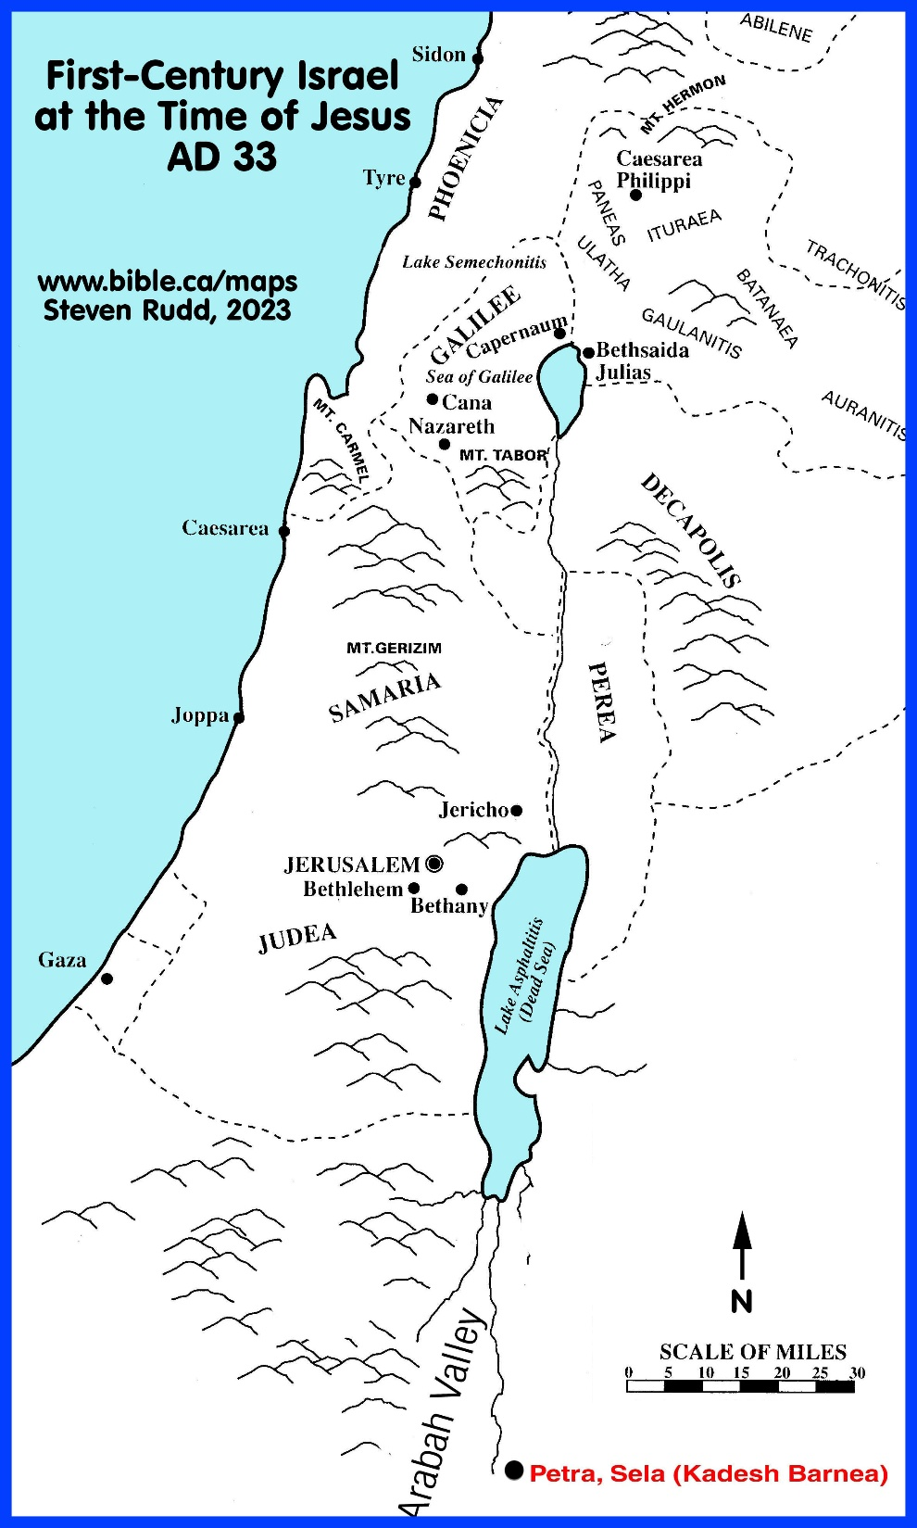**John 7:37-39 – The ones believing receive the Spirit**