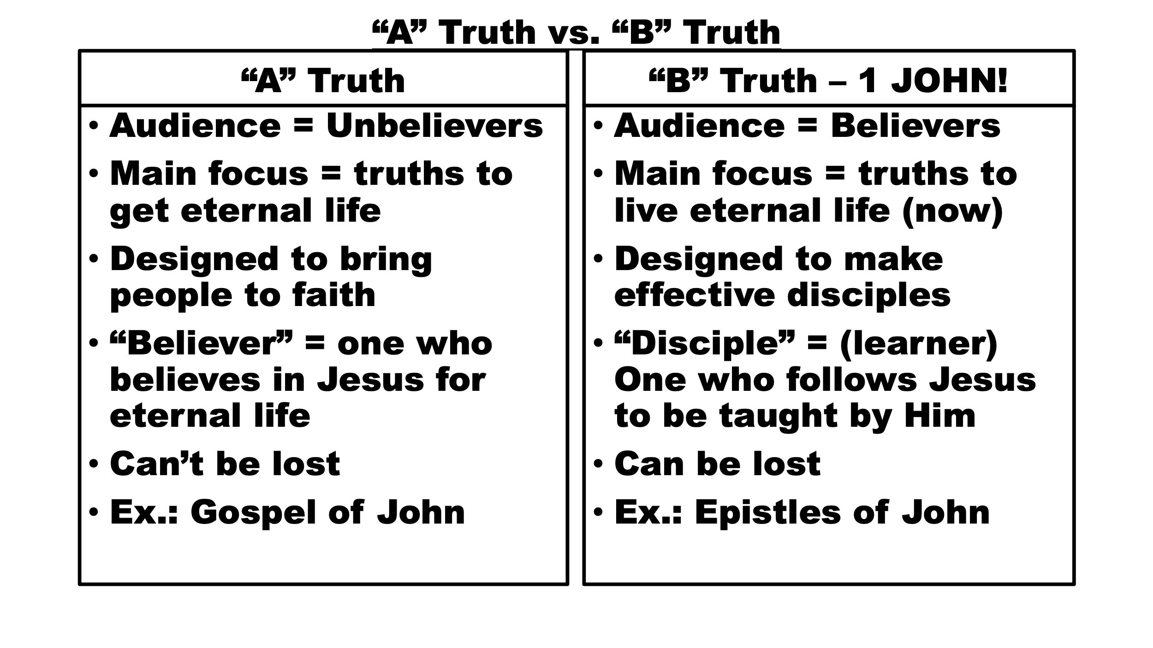
John 12:26-49 – Does Jesus Embarrass You?

Immediate context: Recent themes
- Jesus' hour has now come
- Focus on who we are living for, suffering and sacrifice, preparation for the kingdom for those who believe; Dying to self multiplies impact!
- Are we willing to be disciples (learners/students)?
- Notice the development of Heb. 5:7-9
- Jesus learned from His suffering, even though He was already the Son.
- He then became the “Captain" of our suffering to lead us through it.
- 12:10-11 Receptivity; in John, willingness has been, and is, an issue
- As our King, He offers us a share in His reign. As High Priest, He enables us to attain co-heirship (Rom. 8:16-18).
12:27-29
- Jesus knew the time of His suffering and death had arrived (12:23).
- Jesus – “I’m willing to go through suffering, but glorify yourself through it”
- Response = “I have and I will”
12:30-34
- Because of His death, all men are “savable.” Only those who believe will be saved. Others are judged.
- Jesus draws all, though all will not respond and believe (Jn. 6:44-47).
12:35-36
- Jesus is the Light and shows people the way of discipleship
- Faith brings a relationship
- Sons of light can live with God’s guidance
12:37-41
- The “did not believe”, despite the many signs, which led to “They could not believe.”
- Their unwillingness (John 5:38-46) led to hardening
12:42-43
- “Confession” is never linked to the reception of eternal life. It is not a relationship issue; it is a fellowship issue, a discipleship issue, a “B” truth.
- Matthew 10:32
  - Matthew is a book written to believers, for discipleship, as are Mark and Luke. John is written to unbelievers primarily (Jn. 20:30-31).
  - In context, Matthew 10 is teaching discipleship principles (Mt. 10:24-32).
  - Confession involves a public acknowledgement, much like calling on the name of the Lord (Rom. 10:8-14; Ps. 116:12-16; Heb. 4:14, 11:13).
- By not confessing Jesus, the rulers would not be acknowledged by God, commended, and rewarded. They would “walk in darkness” (1 Jn. 2:9-11).
- Since they loved man’s approval more than God’s, they would not get God’s approval, and they would not be acknowledged before Him.
12:44
- To believe in Jesus is to believe in God
- Believing opens the possibility of walking with direction
- V. 47 – See Heb. 9:28
- V. 50 – To believe in Christ is to obey the Father
Take Aways
- Am I willing to “go public” with Jesus? (Acknowledge Him publicly)
  - If we are not, we cannot be taught by Him - Lk. 14:25
  - All believers have everything they need to grow (2 Pet. 1:3-4), but growth is not automatic (Rom 7:14-25; Gal. 5:16-18)
  - Confess = to acknowledge, what believers do Rom. 10:14-15; Prov. 3:5-6; Mt. 10:24-32; See Ps. 116; Gen. 12:8; 13:4; 21:33
  - Whose approval am I living for? Who do you value? Pr. 16:7

