John 18 – Peter’s Denial: A Believer’s Failure can be a Turning Point
Betrayal and Arrest in Gethsemane 18:1-10
- Jesus knew what was coming and asked who they were after. When they said it was Jesus, they fell back to the ground in fear (twice), Jesus being so mean and scary and all.
- Jesus admitted His identity and wanted to protect His men
- Peter cut off the ear of Malchus to defend Jesus
- Peter’s bravery is not in question, though his wisdom might be
- Jesus tells Peter to put his sword away
- 13,392,000,000 More than the entire world today of 8.3 billion. Twelve legions of angels would include a minimum of 72,000 angels, as one legion consists of at least 6,000 angels.
18:11 - The Christ is ready to suffer; remember Mt 20 “Are you able?” They all deserted Him Mk. 14:31, 50
Before the High Priest 18:12-14
- Jesus is first taken to Annas, the father-in-law of the High Priest, Caiaphas who said it was expedient that one many should die for the people
Peter Denies Jesus 18:15-18
- Peter first denies Jesus when asked by the servant girl who kept the door.
Jesus Questioned by the High Priest 18:19-24
- They questioned Jesus about who followed Him and what Jesus taught
- He told them that His teaching had been public and they should know or could ask virtually anyone
Peter Denies Twice More 18:25-17
Denial #2 18:25-26
Denial #3 – 18:26-27
In Pilate’s Court – 18:28-40
- Jesus admitted that He was a King, but “not of this world”
Taking the Place of Barabbas 18:39-40 - A robber is released instead of Jesus

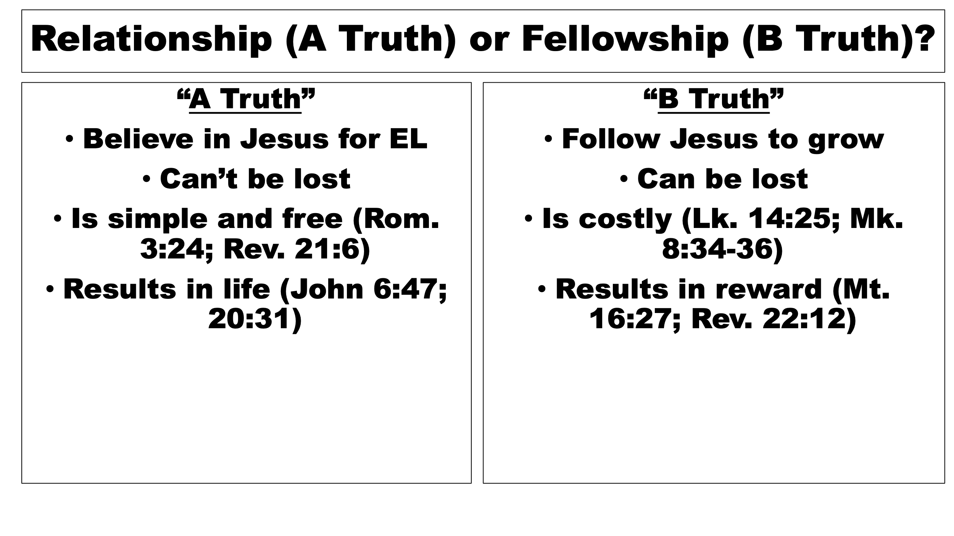


6/7 Day! Applications of John 18
Your failure isn’t the end of the story, but it can be the turning point.
MAIN: Grace doesn’t erase failures—it transforms them.
1. It shows our limitations and the need for the Spirit
Peter wasn’t a coward. He was the one who:
- stepped out of the boat to walk on water
- declared Jesus as the Messiah
- drew a sword in the garden
If he can fall, anyone can. His denial shows that determination and commitment aren’t enough when fear, pressure, and danger collide. It’s a mirror held up to every disciple.
2. It fulfills Jesus’ prophecy
Jesus told Peter, “Before the rooster crows, you will deny Me three times.” When it happens exactly as predicted, it shows:
- Jesus’ foreknowledge
- the reliability of His words
- that nothing happening in the Passion is accidental
Peter’s failure becomes part of the larger divine plan. Fulfilled prophecy = the hand of God and evidence for the Christ (John 20:30-31)
3. It highlights the contrast between Jesus and His disciples
While Peter collapses under pressure:
- Jesus stands firm
- Jesus speaks truth under oath
- Jesus remains faithful even when abandoned
The contrast is intentional. It shows Jesus’ obedience in the face of human frailty. It furthers John’s purpose and shows Jesus is the Christ
4. It prepares the way for Peter’s restoration
The denial sets up one of the most beautiful scenes in Scripture: Jesus asking Peter three times, “Do you love Me?”
The issue wasn’t forgiveness in John 21; it was restoration.
Three denials. Three affirmations. One restored disciple.
Peter’s failure becomes the doorway to grace, humility, and a new kind of leadership. It also molds his character for future service.
5. It shows that failure doesn’t disqualify someone from God’s mission
After denying Jesus publicly:
- Peter becomes the preacher at Pentecost
- Peter becomes a pillar of the early church
- Peter writes letters that strengthen believers to this day
God builds His church with forgiven failures, not perfect people.
This is the man who wrote First Peter, which he ends with “this is the true grace of God; stand firm in it!” He was now a man who better understood grace and dying to self (Mt. 16; Mk. 8; Lk. 9; Jn. 12)
6. It teaches that repentance is the turning point, not perfection
Peter weeps bitterly—not because he’s done, but because his heart is still soft. Judas also betrays Jesus, but his despair leads him to mercy. Peter’s sorrow leads him back to Jesus.
Which direction will you go?
The difference isn’t the size of the sin. It’s the direction of the heart afterward.
7. It brings us into the story
Peter’s denial is universal. Every disciple has moments of silence, compromise, or fear. Peter becomes the representative of all who have failed Christ—and the representative of all who can be restored.
8. Peter’s recovery is built on the reality of a relationship: he knew he could “come home.” 2 Peter 1:5-11 – Never “forget” your forgiveness!
9. Recovery starts with repentance – Lk. 14:25-Ch. 15; repentance leads to restoration
10. Like Peter, our journey may be surprising, with unexpected turns, but it starts and ends with His love, grace, and mercy: John 21:18-19

