Why does Galatians matter to you?
Main: The true Gospel brings true deliverance Key verses: 2:20; 5:25
I don’t do things to become loved and accepted, but because I AM …
1. What is frontloading the Gospel and why does it matter?
- So, what is it? A truth that leads to B truth
- Front-loading the Gospel takes the demands of discipleship and pushes them up into the Gospel. It takes the requirements of discipleship and makes them requirements of salvation.
- A gospel “in process” is never good news.
2. The practical impact of the right view of Justification
- Assurance: I can know I’m going to live forever?
  - The nature of the promise leads to assurance (Jn. 5:24; 6:47)
  - Believers can know they have eternal life – 1 Jn. 5:13
  - Assurance is the basis for appreciation and growth – 1 Jn. 5:13b; Lk. 7:36-50; 2 Pet. 1:9-10
- Security
    - The nature of the Gospel involves security; For example, Jn. 6:33-40; Rom. 5:1; Heb. 10:10-18
    - The offer is called “eternal” life
  - Properly understood, no Scripture indicates eternal life can be lost
    - For example,
      - Blasphemy of the Spirit: not committed by believers
      - Heb. 6 = falling away from the path to maturity
  - Losing life that is eternal is an oxymoron.
- The absence of, or distortion of, growth
  - Our view of others is distorted - Gal. 2:11-21
  - Salvation is a never-ending process; we have no identity
  - We fall from the grace way of life and “short circuit” our goal to the Lordship of Jesus - Gal. 2:20-3:3; 5:4; 5:19-20
  - Our potential future ceases to motivate us – Gal. 4, 5:19-21
  - We see the works of the flesh instead of the Spirit – 5:19-21
  - We end up losing inheritance – 5:21
  - We see believers falling into sin – 6:1f.
  - The focus shifts off of Jesus and His finished work and onto you and your ongoing efforts
  - Consequences lack perspective – 6:8-19
The value of a correct view of the Gospel
- It leads to more growth and appreciation (Lk. 7:36-50; Eph. 3:14-21; 2 Pet. 1:9)
- I’m aware of my God-given “download”; My relationship with God is final and complete; nothing is left to be done.
  - Salvation is final and complete; I’m “in Christ,” and He is in me (Gal. 2:20)
  - I have the Spirit (Gal. 3:2, 6; 5:25)
  - I’m justified (declared righteous) (Gal. 2:16; 3:24)
  - Redeemed (Gal. 3:13; 4:5) Forgiven Col. 2:13
  - Adult Sons of God (Gal. 3:26; 4:7)
  - Heirs of God (Gal. 3:29; 4:7)
  - (Spirit) Baptized into Christ (Gal. 3:27)
3. What is meant by “front-loading” the Gospel (Dr. Hendricks)?
It’s a view that moves the demands of discipleship into the gospel. Instead of believing Jesus’ promise of life by believing, this view often redefines belief and instead demands commitment to Jesus’ Lordship in their life. Any godly believer wants the lordship of Jesus in life. The real issue is, “How do we get there?”
A view that has demands for justification beyond faith ruins growth.
Justification is final and complete! It’s not an ongoing “process”.
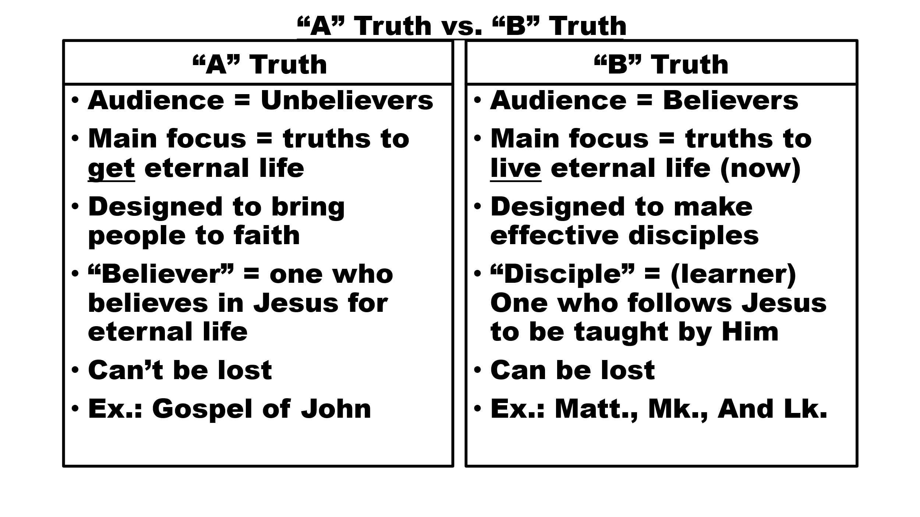
- “A truth” involves our initial relationship to God
- “B truth’ involves our ongoing fellowship with God
- One book, the Gospel of John, is addressed to unbelievers and tells them how to get eternal life
- The other 26 books of the New Testament are addressed to those who have believed and have eternal life that they might become disciples
- Change begins with a new identity
- Our new identity is given to us in Christ
- Self-hatred destroys the process of change

